Middle East and North Africa Map Activity (MENA)
Part I: Using the map on page R22 & 361 of your textbook, label the following countries on the white portion of the map.

Bahrain
Cyprus
Egypt
Iran
Iraq
Israel
Jordan
Kuwait
Lebanon
Oman
Qatar
Saudi Arabia
Syria
Turkey
United Arab Emirates
Yemen

Part II: Using the maps on page R22 & 361 of your textbook, label the following countries that border the MENA (grey area).

Afghanistan
Armenia
Azerbaijan
Georgia
Pakistan
Russia
Turkmenistan

Part III: Use a black dot to label the cities/holy places on the map. Use page 417 for reference.

Jerusalem
Mecca
Medina
Mesopotamia
Tehran

Part IV: Using the map on page R22 & 361 of your textbook, label the following physical features/landforms on the map. Draw a blue line for rivers when necessary.

Aegean Sea
Black Sea
Euphrates River
Gulf of Aden
Gulf of Oman
Indian Ocean
Mediterranean Sea
Persian Gulf
Red Sea
Tigris River

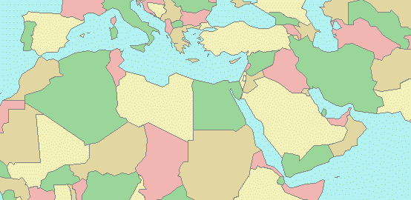

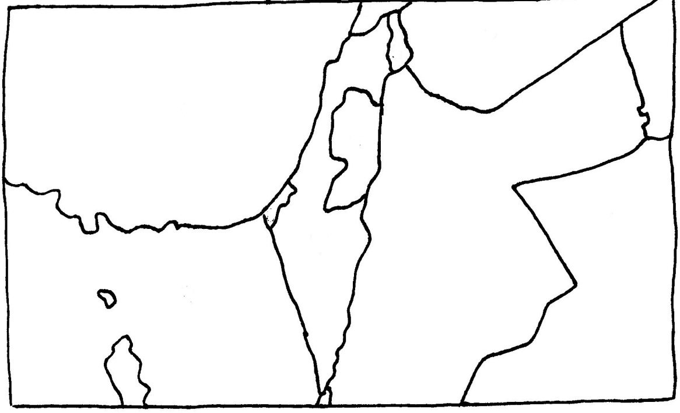
Part V: Using the map on page 403 of your textbook, label the following territories/physical features on the ENLARGED AREA map.

Gaza Strip
Golan Heights
Israel
Jerusalem
Jordan
Mediterranean Sea
Sinai Peninsula
Suez Canal
Syria
West Bank

