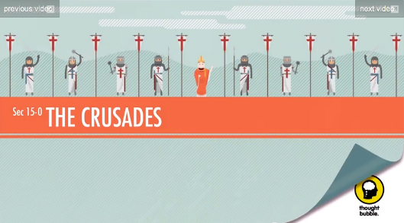
Name ____________________________________ Date__________ Period_________

The Crusades
Directions- Watch the Crash Course World History: The Crusades video and complete the questions below.

Before you start! The Holy Land refers to _______________________________ and when we last spoke it was under the control of the _________________________________.
1. Who are the Seljuk Turks?

2. Who does the Byzantine Emperor turn to for help? Why?

3. Why does Pope Urban II decide to help? (Hint there are 3 reasons!)

4. Did those in the First Crusade retake the Holy Land?

5. The Third Crusade was against whom? What was the result?

6. The Fourth Crusade marked the beginning of the end for which empire? Why? What happens?

Big Picture
7. What overall impact did the Crusades have on the region?

8. Why is the answer to #6 such a big deal?

