NAME: DATE: PERIOD:
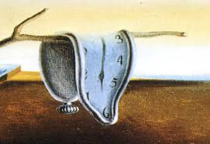
FOCUS: Watch the John Green video Islam, The Koran, and the 5 Pillars and answer the questions below:
1) How many years did it take for Islam to be nonexistent to a major influence in the world?

2) What angel appeared to Muhammad, the founder of Islam?

3) What did Muslims believe about Muhammad?

4) What are some of the themes of the Quran (Koran)?

5) What are the 5 Pillars?

6) What does Islam have that is like Christianity and Judaism?

7) What is the Hijra (not Hajj!)?

8) What happened in 630?

9) Besides being a religious influence, what other influence does Islam have that is different from Christianity and Judaism?

