The Question of Identity: Ethnicity, Language, Religion, and Gender, Before Islam – Mesopotamia
Use details and information from the article “Ethnicity and Language” to complete the chart below.

WHO | WHAT – include information on the types of written or spoken systems utilized by these groups (may go beyond reading and use your device to conduct brief internet search) | WHERE – Whence the group came from (be sure to include the eight cardinal compass directions: N, NE, E, SE, S, SW, W, NW) | WHEN – include information on when each group migrated to Mesopotamia
SUMERINANS |  | Original inhabitants of Mesopotamia
AKKADIANS |  | Original inhabitants of Mesopotamia
AMORITES |  | From the WEST of Mesopotamia
KASSITES
ARAMEANS
GUTIANS
HITTIES
HURRIANS

Now, using the “Where” information from the chart above complete the map below. Identify the region each group inhabited in relation Mesopotamia; then use arrows to indicate the direction of migration of each group to Mesopotamia. An example has been done for you.
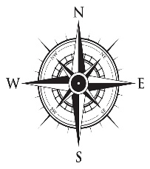

Caption: ________________________________________________________________________________________________________________________________________________________________________________________________________________________________________________________________________________________________________________________________________________________________________________________________________
Compose an original caption for the map, highlighting a particular piece of information. Your caption should state something specific that relates to the map but cannot be figured out from the map alone. This caption is not a summary of the entire map, but highlights one or two things. Your caption must be historically accurate, and should avoid platitudes such as “Many different groups migrated to Mesopotamia in ancient times." A exemplary caption might read as follows: “While the Sumerians may have invented writing with the creation of cuneiform, the Arameans brought the first alphabetic writing system to Mesopotamia.”

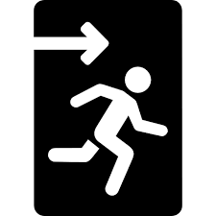
EXIT Questions:
Explain how the new arrivals to ancient Mesopotamia reflect cultural diffusion. Be specific in your response, and use details and evidence from the text to support your answer.
____________________________________________________________________________________________________________________________________________________________________________________________________________________________________________________________________________________________________________________________________________________________________________________________________________________________________________________________________________________________________________________________________________________________________________________________________________________________________________________________________________________________________________________________________________________________________________________________________________________________________________________________________________________________________________________________________________________________________________________________________________________

Based on information provided in the article, is what happened in ancient Mesopotamia an example of acculturation, assimilation, or transculturation. Use evidence from the text to support your response.
____________________________________________________________________________________________________________________________________________________________________________________________________________________________________________________________________________________________________________________________________________________________________________________________________________________________________________________________________________________________________________________________________________________________________________________________________________________________________________________________________________________________________________________________________________________________________________________________________________________________________________________________________________________________________________________________________________________________________________________________________________________

