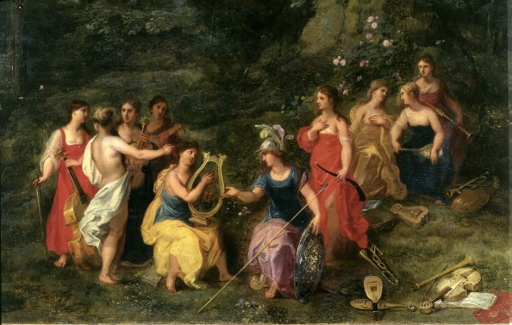
THE ODYSSEY INVOCATION ASSIGNMENT
- Highlight the point where the poet invokes (calls upon) the muse and label it: “invocation”
- Circle the phrases that describe Odysseus. In the margin, note what does the poet want us to know about Odysseus from the beginning?
- Underline sections that suggest that Odysseus is a hero.
- Box the phrases that characterize Odysseus’ journey. List the different things he encounters in the margin.
- Highlight where the poet describes the fate of Odysseus’ men. In the margin, note who is responsible for this fate.

"Sing in me, Muse, and through me tell the story MARGINAL NOTES:
of that man skilled in all ways of contending,*
the wanderer, harried for years on end,
after he plundered the stronghold
on the proud height of Troy.
He saw the townlands
and learned the minds of many distant men,
and weathered many bitter nights and days
in his deep heart at sea, while he fought only
to save his life, to bring his shipmates home.
But not by will nor valor could he save them,
for their own recklessness destroyed them all-
children and fools, they killed and feasted on
the cattle of Lord Helios, the Sun,
and he who moves all day through heaven
took from their eyes the dawn of their return.
Of these adventures, Muse, daughter of Zeus,
tell us in our time, lift the great song again.
Begin when all the rest who left behind them
headlong death in battle or at sea
had long ago returned, while he alone still hungered
for home and wife. Her ladyship Calypso
a nymph, immortal and most beautiful,
who craved him for her own.
And when long years and seasons
wheeling brought around that point of time
ordained for him to make his passage homeward,
trails and dangers, even so, attended him
even in Ithaca, near those he loved.
Yet all the gods had pitied Lord Odysseus,
all but Poseidon, raging clod and rough
against the brave king till he came ashore
at last on his own land...."

Using evidence from the reading answer the questions below using complete sentences.
- What is your first impression of Odysseus? Which of his qualities do you admire? Why?
_____________________________________________________________________________________________________________________________________________________________________________________________________________________________________________________________________________________________________________________________________________________________________________________________________________________________________________________________________________________________________________________________________________________________________________________________________________________________________________________________
- What mistakes were made on Ismarus (the island where the men feasted) and who made them?
____________________________________________________________________________________________________________________________________________________________________________________________________________________________________________________________________________________________________________________________________________________________________________
- What lessons do you think were learned on Ismarus?
____________________________________________________________________________________________________________________________________________________________________________________________________________________________________________________________________________________________________________________________________________________________________________

“INVOCATION” EXIT PROMPT:
“...The story of the Odyssey can be stated briefly. A certain man is absent from home for many years; he is jealously watched by Poseidon, and left desolate. Meanwhile his home is in a wretched plight—suitors are wasting his substance and plotting against his son. At length, tempest-tost, he himself arrives; he makes certain persons acquainted with him; he attacks the suitors with his own hand, and is himself preserved while he destroys them. This is the essence of the plot; the rest is episode.”
~ from Aristotle, about The Odyssey in Poetics
- What claims about The Odyssey does Aristotle make?

- If The Odyssey is 24 books long, then why does Aristotle say that “the story of the Odyssey can be stated briefly”? What does he mean?

