THE ODYSSEY BOOK XI READING QUESTIONS (pages 133-149) one point each
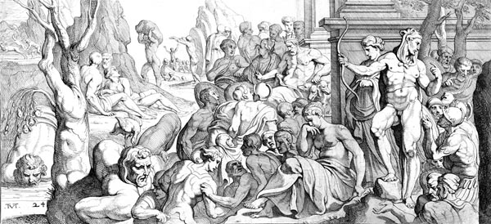
- What does Odysseus sacrifice to the dead? (pgs 133-134)

- What does Odysseus sacrifice to Teiresias? (pg 134)

- What mood does this quote evoke: “When I had made prayer and supplication to the company of the dead, I cut the victims’ throats over the pit, and the red blood poured out. Then the souls of the dead who had passed away came up in a crowd from Erebos: young men and brides, old men how had suffered much, and tender maidens to whom sorrow was a new thing: others killed in battle, warriors clad in bloodstained armour. All this crowd gathered about the pit from every side, with a dreadful great noise, which made me pale with fear”(134)

- Encounter with Elpenor (pgs 134-135)
  - What request does Elpenor, Odysseus’ dead comrade, ask of Odysseus? Use textual evidence to support your response.

  - What motif (recklessness, temptation, monsters, gods, hubris) is emphasized in this interaction. Explain your choice and use textual evidence to support your response.

- Encounter with Teiresias (pgs 135-137)
  - According to Teiresias, who will cause Odysseus trouble? Why? (pg 135)

  - What will Odysseus find on Thrinacia? (pg 135)

  - What will happen to Odysseus if he or his men harm the cattle of Helios, the Sun God? (pgs 135-136) Use textual evidence to support your response.

  - What does Teiresias say Odysseus will find when he returns home? (pg 136)

  - After Odysseus returns home and kills the suitors, to whom should Odysseus make sacrifice? (pg 136)

- Encounter with Anticleia (pgs 137-138)
  - How is Odysseus able to speak to his dead mother?

  - What does Odysseus learn about his wife, son and father? (pgs 137-138)

  - How did Anticleia die? (pg 138)

- Skip to Odysseus encounter with Agamemnon (pgs 143-144)
  - How does Agamemnon’s state now contrast with his state when Odysseus last saw him? (pg 143)

  - Describe the details of Agamemnon’s death (pg 143)

  - What is Agamemnon’s advice for Odysseus? What is the significance of this advice for Odysseus? (pg 144)

- Odysseus encounters Achilles, Heracles, and Ajax all mighty warriors (pgs 145-147). Not a question. Just information. Finally, Odysseus sees Tantalus, tortured by food and drink always just out of reach, and Sisyphus, perpetually pushing a boulder up a hill. The shadows mass in the thousands and frighten away Odysseus, who sails away with his crew.

