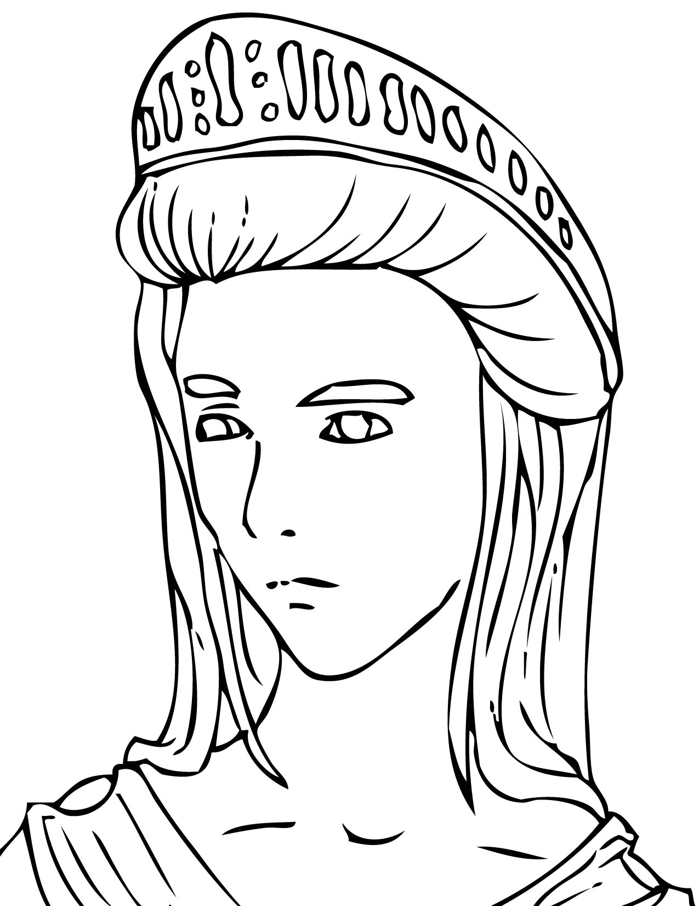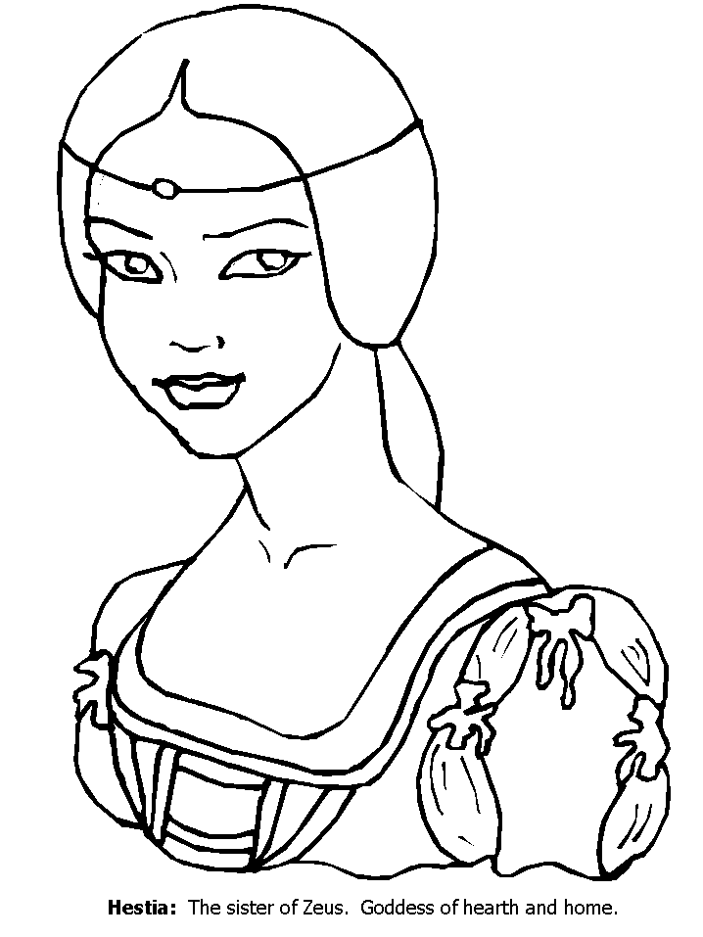

Fears:

Others’ actions towards her:

**Use the Prologue (693-695) for this handout.**

Behavior:

Thoughts:

Statements

Behavior:

Thoughts:

Statements

Fears:

Others’ actions towards her:

Antigone

Ismene