Name: Date: Period:

“Ithaka” Poetry Analysis Questions

Directions: After reading and annotating “Ithaka,” answer the following questions in complete sentences. Use details and evidence from the poem to support your responses. Two points each

- Who do you believe the poet/narrator is addressing? How do you know?
____________________________________________________________________________________________________________________________________________________________________________________________________________________________________________________________________________________________________________________________________________________________________________________________________________________________________

- What three specific dangers will this traveler encounter along his journey?

____________________________________________________________________________________________________________________________________________________________________________________________________________________________________________________________________________________________________________________________________________________________________________________________________________________________________________________________________________________________________________________________________________________________________________________________________________

- What advice does the poet offer in regard to these dangers? Be specific.
________________________________________________________________________________________________________________________________________________________________________________________________________________________________________________________________________________________________________________________________________________________________________________________________________________________________________________________________________________________________________________________

- What does the poet/narrator hope the traveler will do on his way back to “Ithaka?”
____________________________________________________________________________________________________________________________________________________________________________________________________________________________________________________________________________________________________________________________________________________________________________________________________________________________________________________________________________________________________________________________________________________________________________________________________________

- Why does the poet/narrator say “But don’t hurry the journey at all.”
________________________________________________________________________________________________________________________________________________________________________________________________________________________________________________________________________________________________________________________________________________________________________________________________________________________________________________________________________________________________________________________________________________________________________________________________________________________________________________________________________________________________

- The poet/narrator tells the traveler that if having arrived home, he finds Ithaka to be a poor place, he has not been deceived. Why not? What has he learned?

________________________________________________________________________________________________________________________________________________________________________________________________________________________________________________________________________________________________________________________________________________________________________________________________________________________________________________________________________________________________________________________________________________________________________________________________________________________________________________________________________________________________

- Although the island of Ithaka will always be associated with the homeland of Odysseus, in this poem, Cavafy uses the place name in an additional sense. What message is Cavafy really delivering to the reader?

________________________________________________________________________________________________________________________________________________________________________________________________________________________________________________________________________________________________________________________________________________________________________________________________________________________________________________________________________________________________________________________________________________________________________________________________________________________________________________________________________________________________

- What examples of repetition can you find in the poem? List two examples. Why do you believe Cavafy uses repetition in this poem?

________________________________________________________________________________________________________________________________________________________________________________________________________________________________________________________________________________________________________________________________________________________________________________________________________________________________________________________________________________________________________________________________________________________________________________________________________________________________________________________________________________________________

- What is the mood of this poem? How do you feel after reading this poem? Explain. You should have evidence from the text in this answer. Mood is the feeling created in the reader. This feeling is the result of both the tone and author’s language about the subject matter. What feelings or emotions do you experience after reading the poem?

________________________________________________________________________________________________________________________________________________________________________________________________________________________________________________________________________________________________________________________________________________________________________________________________________________________________________________________________________________________________________________________________________________________________________________________________________________________________________________________________________________________________

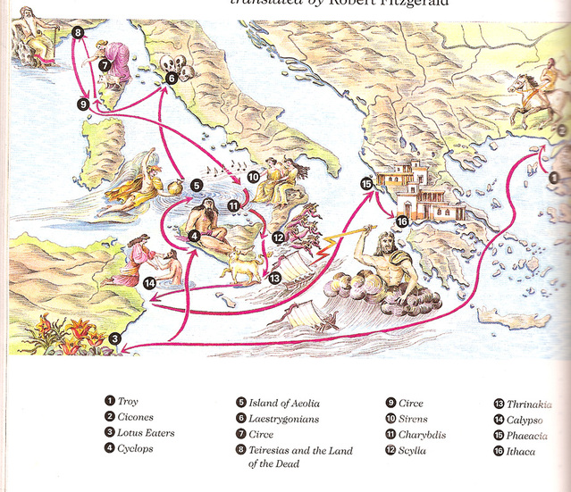
Now, read the following passage from Book 9 of The Odyssey. In this section, Odysseus describes his homeland. Answer the questions below in complete sentences:

The Odyssey (9:212:23-32)
“Sunny Ithaca is my home. Atop her stands our seamark,
Mount Neriton’s leafy ridges shimmering in the wind.
Around her a ring of islands circle side-by-side,
Dulichion, Same, wooded Zacynthus too, but mine
lies low and away, the furthest out to sea,
rearing into the western dusk
while the others face the east and breaking day.
Mine is a rugged land but good for raising sons—
and I myself, I know no sweeter sight on earth
than a man’s own native country.”

- What do the poem and the passage teach the reader about Ithaca? Use details and evidence from both works to support your analysis.

________________________________________________________________________________________________________________________________________________________________________________________________________________________________________________________________________________________________________________________________________________________________________________________________________________________________________________________________________________________________________________________________________________________________________________________________________________________________________________________________________________________________

- What types of figurative language and/or literary devices are used in the poem? In the passage? Provide specific examples.
________________________________________________________________________________________________________________________________________________________________________________________________________________________________________________________________________________________________________________________________________________________________________________________________________________________________________________________________________________________________________________________________________________________________________________________________________________________________________________________________________________________________
- Why is this description important for the reader before beginning a reading of The Odyssey?
________________________________________________________________________________________________________________________________________________________________________________________________________________________________________________________________________________________________________________________________________________________________________________________________________________________________________________________________________________________________________________________________________________________________________________________________________________________________________________________________________________________________

