FAHRENHEIT 451 DOUBLE ENTRY JOURNAL (PAGES 88-89)
Now, carefully and closely read pages 88-89. As you read or after you have read you are responsible for completing FOUR DOUBLE ENTRY JOURNAL RESPONSES. WRITE THE QUOTE (w/ page #) ON THE LEFT AND YOUR ANALYSIS ON THE RIGHT. Base your entry selections on BRADBURY’S use of FIGURATIVE LANGUAGE &/or BRADBURY’S DEVELOPMENT OF MONTAG’S CHARACTER OR THE SETTING.
FAHRENHEIT 451 DOUBLE ENTRY JOURNAL (PAGES 89-97…STOP @ “Mrs. Phelps was crying…”)
Now, carefully and closely read pages 89-97. As you read or after you have read you are responsible for completing FOUR DOUBLE ENTRY JOURNAL RESPONSES. WRITE THE QUOTE (w/ page #) ON THE LEFT AND YOUR ANALYSIS ON THE RIGHT. Base your entry selections on BRADBURY’S use of FIGURATIVE LANGUAGE &/or BRADBURY’S CHARCATER DEVELOPMENT OF MONTAG, MILDRED, FABER, OR CAPTAIN BEATTY.
FAHRENHEIT 451 DOUBLE ENTRY JOURNAL (PAGES 97-106…Begin @ “Mrs. Phelps was crying…”)
Now, carefully and closely read pages 97-106. As you read or after you have read you are responsible for completing FOUR DOUBLE ENTRY JOURNAL RESPONSES. WRITE THE QUOTE (w/ page #) ON THE LEFT AND YOUR ANALYSIS ON THE RIGHT. Base your entry selections on BRADBURY’S use of FIGURATIVE LANGUAGE &/or BRADBURY’S CHARCATER DEVELOPMENT OF MONTAG, MILDRED, FABER, OR CAPTAIN BEATTY. Also, you may focus your entries on Bradbury’s perspective about literature, literacy, and society in the dystopian world of Fahrenheit 451.

Analytical response
- ANALYZE means to break down into smaller parts and examine critically.
- Examine a part of the story: character, plot, mood, setting, theme, and point of view.
- Examine the writer’s style: word choice, sequencing of events, character development, literary devices, sentence style, and point of view
- Sentence starters
  - A problem this character has is ___. I know this problem is significant because . . .
  - A message the author is trying to give through ___(character’s actions, setting, mood) is ___
  - The author is doing a good/poor job of “showing not telling.” I think this because . . .
  - I like/don’t like when the author . . .
  - The character’s attitude about ___ is ___. I think this because…
  - The author has created a ___ mood by . . .
  - The author uses ___(literary device: foreshadowing, flashback, allusion) to . . .
  - The author develops the character well/poorly by . . .
  - My thinking has changed in this way . . .
  - The most important part is . . .
  - I infer . . .

Question
- Question text you do not understand or that confuses you.
- Question the author.
- Question things you have never thought about in order to gain a greater understanding of new concepts. This is the I wonder question, e.g., I wonder how Harry Potter’s decision to leave Hogwarts in his final year to search for Voldemort will affect his reliance on the friendship he has with Ron and Hermoine.
- Question yourself and your own beliefs or understandings if the text prompts you to do so.
- Sentence starters
  - I am confused and this is how I got unstuck . . .
  - Why . . .
  - How . . .
  - I previously thought ____about ____. Now my thinking has changed because . . .
  - I do not understand why the author . . . because . . .

- IN NO WAY SHAPE OR FORM ARE YOU SUMMARIZING IN THE RIGHT COLUMN.

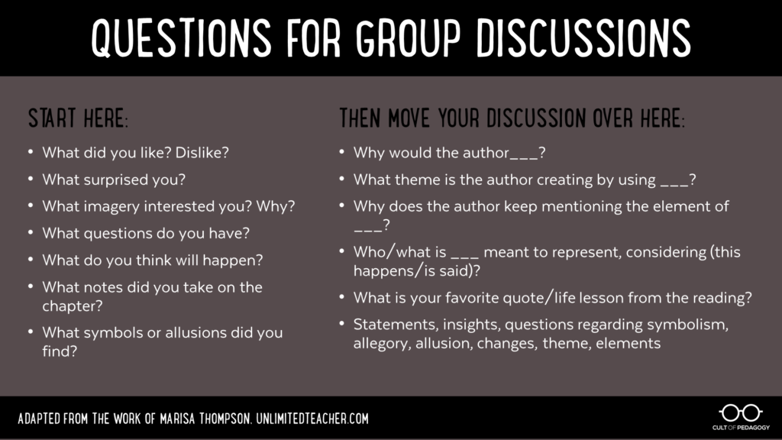

- Peters Township Honor Code: As a student of Peters Township School District, I recognize the value of my own learning and pledge to maintain honesty and academic integrity in all that I do. All work that I submit is my own. Any student that is unsure of the expectations of an assignment should seek clarification from the teacher.

 | 4  Exceeds expectations | 3  Meets expectations | 2  Partially meets expectations | 1/0  Does not meet expectations
Quality of responses | All entries demonstrate deep insight into the text and do an exceptional job of explaining the student’s thoughts through the skillful selection of textual evidence and thoughtful analysis. | All entries demonstrate sufficient insight into the text and adequately explain the student’s thoughts through the selection of textual evidence and analysis. | Some entries demonstrate a lack of insight into the text and do not adequately explain the student’s thoughts. | No evidence of insights beyond simply identifying or restating the speaker and/or circumstances of the passages or quotes.
Quantity of Responses;  Legibility | Includes required number of relevant quotations or passages (on the left side of the double-entry journal) accompanied by student responses to the recorded passages (on the right side of the double-entry journal). Legible handwriting or printing | Includes less than the required relevant quotations or passages (on the left side of the double-entry journal) accompanied by student responses to the recorded passages (on the right side of the double-entry journal). Marginally legible handwriting or printing | Includes less than half of the required quotations or passages (on the left side of the double-entry journal) accompanied by student responses to the recorded passages (on the right side of the double-entry journal).  Writing is not legible in places. | Include no quotations or passages (on the left side of the double-entry journal) accompanied by little to no student responses to the recorded passages (on the right side of the double-entry journal).  Writing is not legible; therefore, no credit for the entire entry.
Relevancy of Quotes | All quotes are thorough, thoughtful, and insightfully relate to the overall meaning of the text. | Most quotes chosen are fairly thorough and adequately relate to the overall meaning of the text. | Some quotes are incomplete or irrelevant. | Many quotes are disjointed, incomplete, or irrelevant.

YOUR SCORE: ______ / 4 = ______ / 3

FAHRENHEIT 451 PAGES 88-106 DOUBLE ENTRY JOURNAL ASSIGNMENT DUE MONDAY, FEBRUARY 17, 2020.

