***FAHRENHEIT 451* CLOSE READING ASSIGNMENT – PAGES 1-21**

|  |  |  |
| --- | --- | --- |
|  |  | |
| It was a pleasure to burn.  It was a special pleasure to see things eaten, to see things blackened and changed. With the brass nozzle in his fists, with this great python spitting its venomous kerosene upon the world, the blood pounded in his head, and his hands were the hands of some amazing conductor playing all the symphonies of blazing and burning to bring down the tatters and charcoal ruins of history. With his symbolic helmet numbered 451 on his stolid head, and his eyes all orange flame with the thought of what came next, he flicked the igniter and the house jumped up in a gorging fire that burned the evening sky red and yellow and black. He strode in a swarm of fireflies. He wanted above all, like the old joke, to shove a marshmallow on a stick in the furnace, while the flapping pigeon-winged books died on the porch and lawn of the house. While the books went up in sparkling whirls and blew away on a wind turned dark with burning.  Montag grinned the fierce grin of all men singed and driven back by flame.  He knew that when he returned to the firehouse, he might wink at himself, a minstrel man, burnt-corked, in the mirror. Later, going to sleep, he would feel the fiery smile still gripped by his face muscles, in the dark. It never went away, that, smile, it never ever went away, as long as he remembered (Bradbury 1) | **METAPHOR: Figure of speech that makes a comparison b/w two unlike things w/o using a connective word such *as like, as, than, or resembles.*** | |
| 1. **[Bracket the METAPHORS] paragraph two.** | |
| **Imagery: Language that appeals to the senses. Most images are visual – appeal to sense of sight. Imagery may also appeal to the senses of sound, smell, touch, and taste.**   1. **Underline the IMAGERY in the first FOUR PARAGRAPHS.** | |
| **Character: Individual in a story, poem, or play. DIRECT – writer tells us directly what the character is like. INDIRECT – readers have to put clues together to figure out what a character is like.** | |
| 1. **What does BRADBURY reveal about Montag’s character based on his feelings, actions, and thoughts in the opening paragraphs of the novel?** | |
| He turned the corner.  The autumn leaves blew over the moonlit pavement in such a way as to make the girl who was moving there seem fixed to a sliding walk, letting the motion of the wind and the leaves carry her forward. Her head was half bent to watch her shoes stir the circling leaves. Her face was slender and milk-white, and in it was a kind of gentle hunger that touched over everything with tireless curiosity. It was a look, almost, of pale surprise; the dark eyes were so fixed to the world that no move escaped them. Her dress was white and it whispered. He almost thought he heard the motion of her hands as she walked, and the infinitely small sound now, the white stir of her face turning when she discovered she was a moment away from a man who stood in the middle of the pavement waiting (Bradbury 3). | **Imagery: Language that appeals to the senses. Most images are visual – appeal to sense of sight. Imagery may also appeal to the senses of sound, smell, touch, and taste.** | |
| 1. **UNDERLINE the IMAGERY Bradbury uses in this paragraph.** | |
| **Inference is the process of arriving at a conclusion using known**[**evidence**](http://www.literarydevices.com/evidence/)**or premises and logically forming an opinion or interpretation.** | |
| 1. **Based on the IMAGERY in the passage, what INFERENCES can reader’s draw about “the girl?”** | |
| "Kerosene," he said, because the silence had lengthened, "is nothing but perfume to me."  "Does it seem like that, really?"  "Of course. Why not?"  She gave herself time to think of it. "I don't know." She turned to face the sidewalk going toward their homes. "Do you mind if I walk back with you? I'm Clarisse McClellan."  "Clarisse. Guy Montag. Come along. What are you doing out so late wandering around? How old are you?"  They walked in the warm-cool blowing night on the silvered pavement and there was the faintest breath of fresh apricots and strawberries in the air, and he looked around and realized this was quite impossible, so late in the year.  **There was only the girl walking with him now, her face bright as snow in the moonlight**, and he knew she was working his questions around, seeking the best answers she could possibly give.  "Well," she said, "I'm seventeen and I'm crazy. My uncle says the two always go together. When people ask your age, he said, always say seventeen and insane. Isn't this a nice time of night to walk? I like to smell things and look at things, and sometimes stay up all night, walking, and watch the sun rise."  They walked on again in silence and finally she said, thoughtfully, "You know, I'm not afraid of you at all."  He was surprised. "Why should you be?"  "So many people are. Afraid of firemen, I mean. But you're just a man, after all..." (Bradbury 4-5) | 1. **Based on what readers know about Montag’s CHARACTER, why is “Kerosene…nothing but perfume to [him]?** | |
| 1. **UNDDERLINE THE IMAGERY IN THE PARAGRAPHS** 2. **Identify the literary device that is BOLDED.**   **__________________________________________________________**   1. **What IMAGES are associated with Clarisse’s character, and in what way(s) do these IMAGES CONTRAST with the IMAGES in the first four paragraphs of the novel?** | |
| 1. **What character does Clarisse McLellan remind you of (think about “The Pedestrian”) & WHY?** | |
| He saw himself in her eyes, suspended in two shining drops of bright water, himself dark and tiny, in fine detail, the lines about his mouth, everything there, as if her eyes were two miraculous bits of violet amber that might capture and hold him intact. Her face, turned to him now, was fragile milk crystal with a soft and constant light in it. It was not the hysterical light of electricity but-what? But the strangely comfortable and rare and gently flattering light of the candle. **One time, when he was a child, in a power-failure, his mother had found and lit a last candle and there had been a brief hour of rediscovery, of such illumination that space lost its vast dimensions and drew comfortably around them, and they, mother and son, alone, transformed,** hoping that the power might not come on again too soon .... (Bradbury 5) | 1. **[BRACKET] THE METAPHROS IN THIS PARAGRAPH.** 2. **Based on the IMAGERY you underlined for questions 4 & 7 and the METAPHORS you [BRACKETED], why would BRADBURY CHARACTERIZE Clarisse McLellan in this way?** 3. **What does the candle SYMBOLIZE?** | |
| 1. **Now, read pages 5-9 (to “He opened the bedroom door”(Bradbury 9). Record ONE SIGNIFICANT THOUGHT you had about the text:** | | |
| He opened the bedroom door.  It was like coming into the cold marbled room of a mausoleum after the moon had set. Complete darkness, not a hint of the silver world outside, the windows tightly shut, the chamber a tomb-world where no sound from the great city could penetrate. The room was not empty.  He listened.  The little mosquito-delicate dancing hum in the air, the electrical murmur of a hidden wasp snug in its special pink warm nest. The music was almost loud enough so he could follow the tune.  He felt his smile slide away, melt, fold over, and down on itself like a tallow skin, like the stuff of a fantastic candle burning too long and now collapsing and now blown out. Darkness. He was not happy. He was not happy. He said the words to himself. He recognized this as the true state of affairs. He wore his happiness like a mask and the girl had run off across the lawn with the mask and there was no way of going to knock on her door and ask for it back. (Bradbury 9) | | 1. **Underline the IMAGERY in this passage.** |
| 1. **[BRACKET] the SIMILIES & METAPHORS** |
| 1. **How does BRADBURY’s use of these literary devices further help develop MONTAG’s CHARACTER?** |
| Without turning on the light he imagined how this room would look. His wife stretched on the bed, uncovered and cold, like a body displayed on the lid of a tomb, **her eyes fixed to the ceiling by invisible threads of steel, immovable.** And in her ears the little Seashells, the thimble radios tamped tight, and an electronic ocean of sound, of music and talk and music and talk coming in, coming in on the shore of her unsleeping mind. The room was indeed empty. Every night the waves came in and bore her off on their great tides of sound, floating her, wide-eyed, toward morning. There had been no night in the last two years that Mildred had not swum that sea, had not gladly gone down in it for the third time.  The room was cold but nonetheless he felt he could not breathe. He did not wish to open the curtains and open the French windows, for he did not want the moon to come into the room. So, with the feeling of a man who will die in the next hour for lack of air, he felt his way toward his open, separate, and therefore cold bed.  An instant before his foot hit the object on the floor he knew he would hit such an object. It was not unlike the feeling he had experienced before turning the corner and almost knocking the girl down. His foot, sending vibrations ahead, received back echoes of the small barrier across its path even as the foot swung. His foot kicked. The object gave a dull clink and slid off in darkness (Bradbury 10) | | 1. **[BRACKET] the SIMILE.** 2. **Why would BRADBURY write “The room was indeed empty” if MILDRED is physically sleeping in the room? Use details from the passage to support your response.** |
| 1. **Record the SIMILIES & METAPHORS BRADBURY uses to describe MILDRED’S CHARACTER on page 11.** | | |
| 1. **Reread the description of Clarisse’s CHARACTER above. How does BRADBURY’s use of FIGURATIVE LANGUAGE differ in the description of these two women? Also, compare CLARISSE’S eyes with MILDRED’s eyes.** | | |
| ***FAHRENHEIT 451* DOUBLE ENTRY JOURNAL (PAGES 11-15 – STOP @ PAGE BREAK)**  **Now, carefully and closely read pages 11-15. As you read or after you have read you are responsible for completing TWO DOUBLE ENTRY JOURNAL RESPONSES. WRITE THE QUOTE (w/ page #) ON THE LEFT AND YOUR ANALYSIS ON THE RIGHT. Base your entry selections on BRADBURY’S use of FIGURATIVE LANGUAGE &/or BRADBURY’S CHARACTERIZATION OF MONTAG, CLARISSE, or MILDRED.** | | |
|  | |  |
|  | |  |
| ***FAHRENHEIT 451* DOUBLE ENTRY JOURNAL PAGES 15-21 (STOP @ PAGE BREAK).**  **Now, carefully read pages 15-21. As you read or after you have read you are responsible for completing FOUR DOUBLE ENTRY JOURNAL RESPONSES. WRITE THE QUOTE (w/ page #) ON THE LEFT & YOUR ANALYSIS ON THE RIGHT. Base your entry selections on BRADBURY’S use of FIGURATIVE LANGUAGE &/or BRADBURY’S CHARACTERIZATION OF MONTAG, CLARISSE, or MILDRED.** | | |
|  | |  |
|  | |  |
|  | |  |
|  | |  |

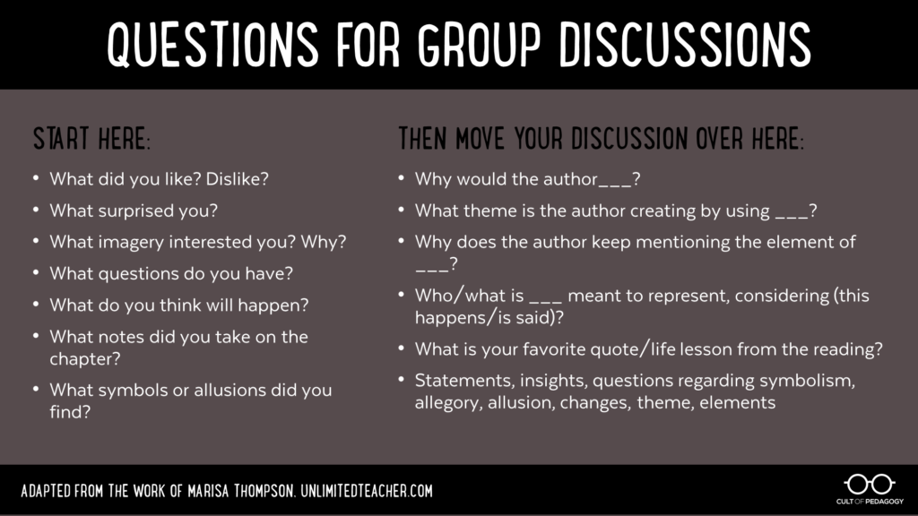

You may use the questions above as a guide to developing coherent and clear responses to the details you selected for your DOUBLE ENTRY JOURNAL.

|  |  |  |  |  |
| --- | --- | --- | --- | --- |
|  | **4**  **Exceeds expectations** | **3**  **Meets expectations** | **2**  **Partially meets expectations** | **1/0**  **Does not meet expectations** |
| **Quality of responses** | All entries demonstrate deep insight into the text and do an exceptional job of explaining the student’s thoughts through the skillful selection of textual evidence and thoughtful analysis. | All entries demonstrate sufficient insight into the text and adequately explain the student’s thoughts through the selection of textual evidence and analysis. | Some entries demonstrate a lack of insight into the text and do not adequately explain the student’s thoughts. | No evidence of insights beyond simply identifying or restating the speaker and/or circumstances of the passages or quotes. |
| **Quantity of Responses;**  **Legibility** | Includes required number of relevant quotations or passages (on the left side of the double-entry journal) accompanied by student responses to the recorded passages (on the right side of the double-entry journal). Legible handwriting or printing | Includes less than the required relevant quotations or passages (on the left side of the double-entry journal) accompanied by student responses to the recorded passages (on the right side of the double-entry journal). Marginally legible handwriting or printing | Includes less than half of the required quotations or passages (on the left side of the double-entry journal) accompanied by student responses to the recorded passages (on the right side of the double-entry journal).  Writing is not legible in places. | Include no quotations or passages (on the left side of the double-entry journal) accompanied by little to no student responses to the recorded passages (on the right side of the double-entry journal).  **Writing is not legible; therefore, no credit for the entire entry.** |
| **Relevancy of Quotes** | All quotes are thorough, thoughtful, and insightfully relate to the overall meaning of the text. | Most quotes chosen are fairly thorough and adequately relate to the overall meaning of the text. | Some quotes are incomplete or irrelevant. | Many quotes are disjointed, incomplete, or irrelevant. |

**YOUR SCORE: ______ / 4 = ______ / 3**

* **Peters Township Honor Code**:  As a student of Peters Township School District, I recognize the value of my own learning and pledge to maintain honesty and academic integrity in all that I do.  All work that I submit is my own.  Any student that is unsure of the expectations of an assignment should seek clarification from the teacher.