FAHRENHEIT 451 DOUBLE ENTRY JOURNAL RESPONSES (PAGES 21-45) –DUE WEDNESDAY, JANUARY 22, 2019
Foreshadowing: The use of clues to hint at events that will occur later in the plot. | Carefully read and listen to Bradbury’s description of the Mechanical Hound and Montag’s interaction with the Mechanical Hound (21-25)
LIST THE DETAILS BRADBURY USES TO DESCRIBE THE MECHANICAL HOUND (include page #s): | Now, what might BRADBURY be FORESHADOWING based on Montag’s interaction with the MECHANICAL HOUND? Why do you think this?
One two three four five six seven days. And as many times he came out of the house and Clarisse was there somewhere in the world. Once he saw her shaking a walnut tree, once he saw her sitting on the lawn knitting a blue sweater, three or four times he found a bouquet of late flowers on his porch, or a handful of chestnuts in a little sack, or some autumn leaves neatly pinned to a sheet of white paper and thumbtacked to his door. Every day Clarisse walked him to the corner. One day it was raining, the next it was clear, the day after that the wind blew strong, and the day after that it was mild and calm, and the day after that calm day was a day like a furnace of summer and Clarisse with her face all sunburnt by late afternoon. (Bradbury 25) | - What do Clarisse’s ACTIONS reveal about her CHARACTER? HOW DO CLARISSE’S ACTIONS compare to MILDRED’S ACTIONS? WHY do you think BRADBURY draws these distinctions?
"Why is it," he said, one time, at the subway entrance, "I feel I've known you so many years?"  "Because I like you," she said, "and I don't want anything from you. And because we know each other."  "You make me feel very old and very much like a father." "Now you explain," she said, "why you haven't any daughters like me, if you love children so much?"  "I don't know."  "You're joking!"  "I mean-" He stopped and shook his head. "Well, my wife, she . . . she just never wanted any children at all." The girl stopped smiling. "I'm sorry. I really, thought you were having fun at my expense. I'm a fool."  "No, no," he said. "It was a good question. It's been a long time since anyone cared enough to ask. A good question."  "Let's talk about something else. Have you ever smelled old leaves? Don't they smell like cinnamon? Here. Smell."  "Why, yes, it is like cinnamon in a way."  She looked at him with her clear dark eyes. "You always seem shocked."  "It's just I haven't had time--"  "Did you look at the stretched-out billboards like I told you?"  "I think so. Yes." He had to laugh.  "Your laugh sounds much nicer than it did"  "Does it?" "Much more relaxed."  He felt at ease and comfortable. "Why aren't you in school? I see you every day wandering around."(Bradbury 26) | DIALOGUE: Conversation between two or more characters.
 | - What does the DIALOGUE between CLARISSE & MONTAG reveal about each CHARACTER?
"Oh, they don't miss me," she said. "I'm anti-social, they say. I don't mix. It's so strange. I'm very social indeed. It all depends on what you mean by social, doesn't it? Social to me means talking about things like this." She rattled some chestnuts that had fallen off the tree in the front yard. "Or talking about how strange the world is. Being with people is nice. But I don't think it's social to get a bunch of people together and then not let them talk, do you? An hour of TV class, an hour of basketball or baseball or running, another hour of transcription history or painting pictures, and more sports, but do you know, we never ask questions, or at least most don't; they just run the answers at you, bing, bing, bing, and us sitting there for four more hours of filmteacher. That's not social to me at all. It's a lot of funnels and a lot of water poured down the spout and out the bottom, and them telling us it's wine when it's not. They run us so ragged by the end of the day we can't do anything but go to bed or head for a Fun Park to bully people around, break windowpanes in the Window Smasher place or wreck cars in the Car Wrecker place with the big steel ball. Or go out in the cars and race on the streets, trying to see how close you can get to lamp-posts, playing `chicken' and 'knock hub-caps.' I guess I'm everything they say I am, all right. I haven't any friends. That's supposed to prove I'm abnormal. But everyone I know is either shouting or dancing around like wild or beating up one another. Do you notice how people hurt each other nowadays?"  "You sound so very old."  "Sometimes I'm ancient. I'm afraid of children my own age. They kill each other. Did it always used to be that way? My uncle says no. Six of my friends have been shot in the last year alone. Ten of them died in car wrecks. I'm afraid of them and they don't like me because I'm afraid. My uncle says his grandfather remembered when children didn't kill each other. But that was a long time ago when they had things different. They believed in responsibility, my uncle says. Do you know, I'm responsible. I was spanked when I needed it, years ago. And I do all the shopping and house-cleaning by hand.  "But most of all," she said, "I like to watch people. Sometimes I ride the subway all day and look at them and listen to them. I just want to figure out who they are and what they want and where they're going. Sometimes I even go to the Fun Parks and ride in the jet cars when they race on the edge of town at midnight and the police don't care as long as they're insured. As long as everyone has ten thousand insurance everyone's happy. Sometimes I sneak around and listen in subways. Or I listen at soda fountains, and do you know what?"  "What?" "People don't talk about anything."  "Oh, they must!" (Bradbury 26-28) | - HOW does CLARISSE define “social?” HOW does society/school define “social?” ~ What is DIFFERENT about each definition?  - Explain the METAPHOR BRADBURY uses here.
 | - HOW does BRADBURY DESCRIBE the way kids in this society entertain themselves? What is your reaction to this?
"No, not anything. They name a lot of cars or clothes or swimming-pools mostly and say how swell! But they all say the same things and nobody says anything different from anyone else. And most of the time in the cafes they have the joke-boxes on and the same jokes most of the time, or the musical wall lit and all the colored patterns running up and down, but it's only color and all abstract. And at the museums, have you ever been? All abstract. That's all there is now. My uncle says it was different once. A long time back sometimes pictures said things or even showed people."  "Your uncle said, your uncle said. Your uncle must be a remarkable man."  "He is. He certainly is. Well, I've got to be going. Goodbye, Mr. Montag." "Good-bye." "Good-bye...." (Bradbury 28) | - What do people talk about in this society? How is this different from our own society? Why do you think Clarisse has such a problem with everything being “abstract”?
One two three four five six seven days: the firehouse.  "Montag, you shin that pole like a bird up a tree."  Third day.  "Montag, I see you came in the back door this time. The Hound bother you?" "No, no."  Fourth day.  "Montag, a funny thing. Heard tell this morning. Fireman in Seattle, purposely set a Mechanical Hound to his own chemical complex and let it loose. What kind of suicide would you call that?"  Five six seven days.  And then, Clarisse was gone. He didn't know what there was about the afternoon, but it was not seeing her somewhere in the world. The lawn was empty, the trees empty, the street empty, and while at first he did not even know he missed her or was even looking for her, the fact was that by the time he reached the subway, there were vague stirrings of un-ease in him. Something was the matter, his routine had been disturbed. A simple routine, true, established in a short few days, and yet . . . ? He almost turned back to make the walk again, to give her time to appear. He was certain if he tried the same route, everything would work out fine. But it was late, and the arrival of his train put a stop to his plan. (Bradbury 29) | Repetition: literary device that repeats the same words or phrases a few times to make an idea clearer and more memorable. ... As a rhetorical device, it could be a word, a phrase, or a full sentence, or a poetical line repeated to emphasize its significance in the entire text.
 | - How does BRADBURY’S repeated use of the word “empty” illustrate how MONTAG feels not only at this moment but throughout the text as whole?
FAHRENHEIT 451 DOUBLE ENTRY JOURNAL (PAGES 29-32 – STOP @ PAGE BREAK)
Now, carefully and closely read pages 29-32. As you read or after you have read you are responsible for completing TWO DOUBLE ENTRY JOURNAL RESPONSES. WRITE THE QUOTE (w/ page #) ON THE LEFT AND YOUR ANALYSIS ON THE RIGHT. Base your entry selections on BRADBURY’S use of FIGURATIVE LANGUAGE &/or BRADBURY’S CHARACTERIZATION OF MONTAG, CLARISSE, MILDRED, or CAPTAIN BEATTY.
FAHRENHEIT 451 DOUBLE ENTRY JOURNAL (PAGES 29-32 – STOP @ PAGE BREAK)
Now, carefully and closely read pages 32-45. As you read or after you have read you are responsible for completing FOUR DOUBLE ENTRY JOURNAL RESPONSES. WRITE THE QUOTE (w/ page #) ON THE LEFT AND YOUR ANALYSIS ON THE RIGHT. Base your entry selections on BRADBURY’S use of FIGURATIVE LANGUAGE &/or BRADBURY’S CHARACTERIZATION OF MONTAG, CLARISSE, MILDRED, or CAPTAIN BEATTY.

- Peters Township Honor Code: As a student of Peters Township School District, I recognize the value of my own learning and pledge to maintain honesty and academic integrity in all that I do. All work that I submit is my own. Any student that is unsure of the expectations of an assignment should seek clarification from the teacher.

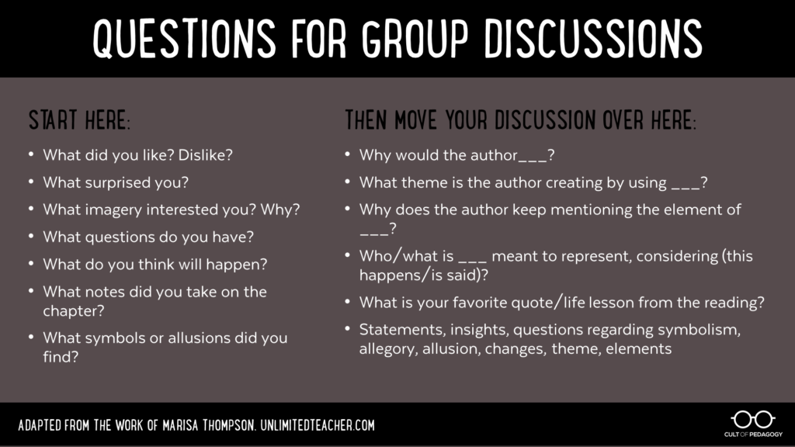

You may use the questions above as a guide to developing coherent and clear responses to the details you selected for your DOUBLE ENTRY JOURNAL.
 | 4  Exceeds expectations | 3  Meets expectations | 2  Partially meets expectations | 1/0  Does not meet expectations
Quality of responses | All entries demonstrate deep insight into the text and do an exceptional job of explaining the student’s thoughts through the skillful selection of textual evidence and thoughtful analysis. | All entries demonstrate sufficient insight into the text and adequately explain the student’s thoughts through the selection of textual evidence and analysis. | Some entries demonstrate a lack of insight into the text and do not adequately explain the student’s thoughts. | No evidence of insights beyond simply identifying or restating the speaker and/or circumstances of the passages or quotes.
Quantity of Responses;  Legibility | Includes required number of relevant quotations or passages (on the left side of the double-entry journal) accompanied by student responses to the recorded passages (on the right side of the double-entry journal). Legible handwriting or printing | Includes less than the required relevant quotations or passages (on the left side of the double-entry journal) accompanied by student responses to the recorded passages (on the right side of the double-entry journal). Marginally legible handwriting or printing | Includes less than half of the required quotations or passages (on the left side of the double-entry journal) accompanied by student responses to the recorded passages (on the right side of the double-entry journal).  Writing is not legible in places. | Include no quotations or passages (on the left side of the double-entry journal) accompanied by little to no student responses to the recorded passages (on the right side of the double-entry journal).  Writing is not legible; therefore, no credit for the entire entry.
Relevancy of Quotes | All quotes are thorough, thoughtful, and insightfully relate to the overall meaning of the text. | Most quotes chosen are fairly thorough and adequately relate to the overall meaning of the text. | Some quotes are incomplete or irrelevant. | Many quotes are disjointed, incomplete, or irrelevant.

YOUR SCORE: ______ / 4 = ______ / 3

