NAME:
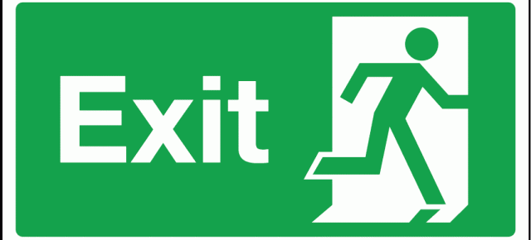
EXODOS EXIT TICKET:
"Where love rules, there is no will to power; and where power predominates, there love is lacking. The one is the shadow of the other." -- Carl Jung
To what extent is this quotation related to King Creon and his regime? Does this statement about power justify Creon's actions? Why or why not?
____________________________________________________________________________________________________________________________________________________________________________________________________________________________________________________________________________________________________________________________________________________________________________________________________________________________________________________________________________________________________________________________________________________________________________________________________________________________________________________________________________________________________________________________________________________________________________________________________________________________________________________________________________________________________________________________________________________________________________________________________________________

NAME:
EXODOS EXIT TICKET:
"Where love rules, there is no will to power; and where power predominates, there love is lacking. The one is the shadow of the other." -- Carl Jung
To what extent is this quotation related to King Creon and his regime? Does this statement about power justify Creon's actions? Why or why not?
____________________________________________________________________________________________________________________________________________________________________________________________________________________________________________________________________________________________________________________________________________________________________________________________________________________________________________________________________________________________________________________________________________________________________________________________________________________________________________________________________________________________________________________________________________________________________________________________________________________________________________________________________________________________________________________________________________________________________________________________________________________

