CLEVER & COMMONLIT INFORMATION
- Go to clever.com and click on “Log in as a student”
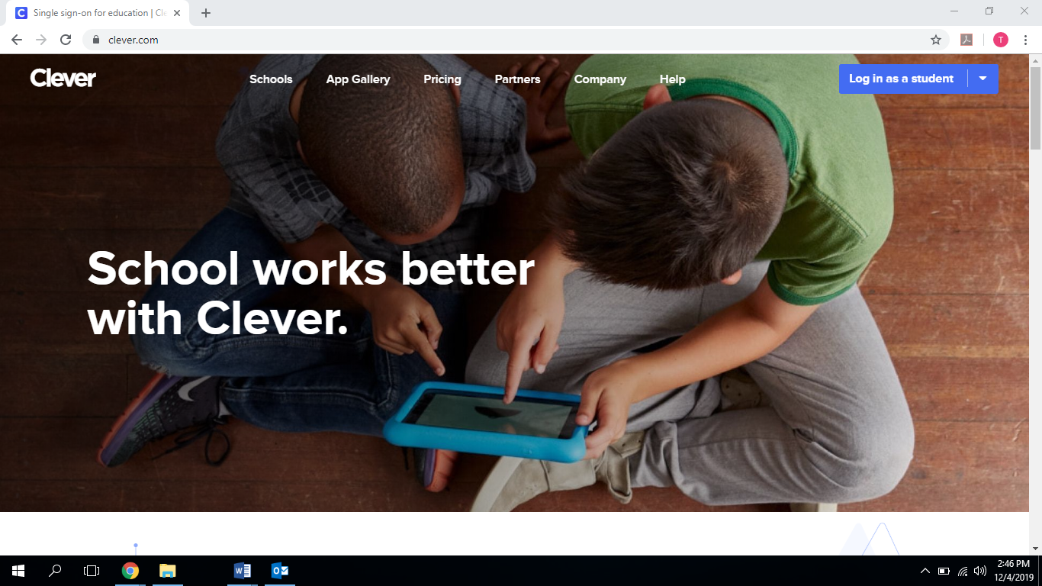

- Select “Log in with Active Directory”

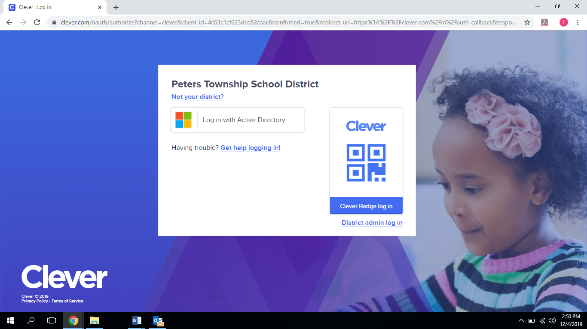

- Log in with your ptsdwebapps.com user name and network password
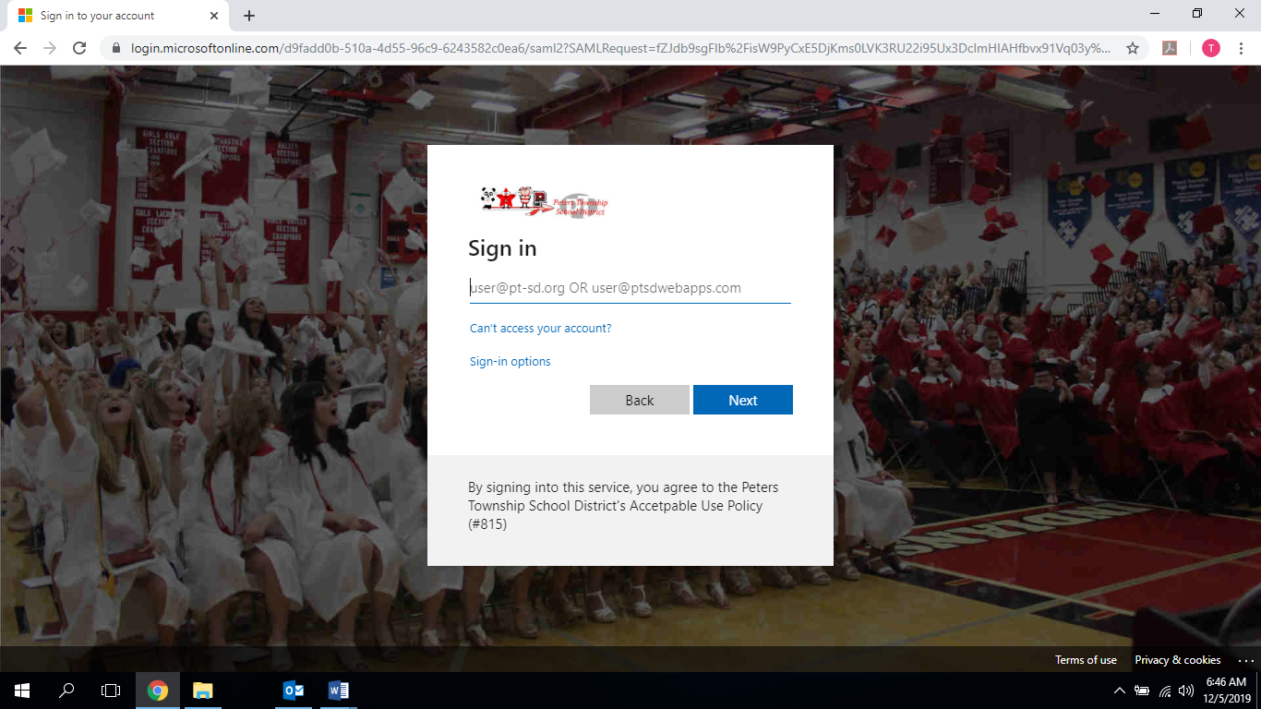
- Once you are in Clever, select Learning Application Portals from the links on the left-hand side of the page

- Select Commonlit

- Commonlit will/may prompt you to update your account. Please use your ID number as your password.

- Go to MY ASSIGNMENTS at the top of your screen

- Select “The Science of Solitary Confinement”

- Use the annotation tool to complete the assignment. See instructions below.

ANNOTATION ASSIGNMENT

- BEFORE READING:
  - Set purpose for reading. Consider what it means by asking a question about the title.
  - Identify the topic/subject and WRITE anything you already know about the topic and anything you want to know about the topic.

- DURING READING:
  - Write in the margins:
  - Summarize
  - Make predictions
  - Formulate opinions (agree or disagree with the author)
  - Make connections
  - Ask questions (Clarify/Connect/Conclude)
  - Analyze author’s point of view (tone, diction, syntax)
  - Write reflections/reactions/comments

- AFTER READING
  - Complete this statement, “The author’s purpose for writing this is…”
  - If you can’t answer author’s purpose questions, go back and reread the introduction and conclusion. Go back to the title and ANSWER your question and write a reflection on the significance of the title.

Your annotation will be scored based on the following guidelines:
10 – The student demonstrates strong comprehension of the text. He/she identifies significant textual examples for analysis that reflect the specific items outlined in the annotation guide. The student shows thoughtful reflection on the examples in his/her annotations and develops insightful analysis of the meaning, purpose, or effect of the text identified.
8.5 – The student demonstrates adequate comprehension of the text. He/she identifies relevant textual examples for analysis, but may not reflect all of the items outlined in the guide. The student offers satisfactory analysis of the meaning, purpose, or effect of the examples in his/her annotations, but some analysis may lack depth or may be inaccurate.
7 – The student demonstrates some lack of understanding of the text through inaccuracies. He/she identifies some relevant portions of the text but some examples are not significant or do not reflect the items in the guide. Some attempt at analyzing meaning, purpose, or effect is made, but the analysis is superficial or thin.
6 – The student demonstrates significant misunderstanding of the text in his/her paraphrase and ID of purpose and tone. He/she identifies some significant portions of the text, but makes a minimal attempt to offer analysis of meaning, purpose, or effect.
4 – The student offers some annotations, but they are unacceptably minimal and/or demonstrate a significant misunderstanding of the text. The annotations provide no attempt to offer analysis of meaning, purpose, or effect.

