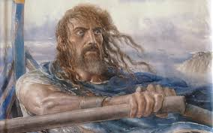
Directions: As you read, use the chart below to keep track of major (and some minor, who play a major role) characters in the Odyssey. Characters marked with * are recurring characters who play significant roles throughout the story!

BOOK I (pages 3-15)  &  NAME OF CHARACTER | DESCRIPTION OF CHARCATER with PAGE # where character is introduced (including significant relationships with other characters) | DESCRIPTION OF ROLE they play in the plot of Odysseus’s journey | CHARACTERIZATION (DIRECT or INDIRECT)
*Zeus
*Poseidon | “…he expected a fine sacrifice of bulls and goats, and there he was, feasting and enjoying himself mightily” (3) – Poseidon is one of the major gods and is determined to prevent Odysseus from getting home to Ithaca. | “…Poseidon Earthhoder bears [Odysseus] unrelenting hatred, because of the Cyclops whose eye [Odysseus] put out; I mean Polyphemous, who has our blood in his veins, the most powerful of all the Cyclopians”(5) and “has kept [Odysseus] wandering about, although he does not kill him outright”(5). | INDRIECT  (Actions)
*Athena
*Hermes
*Penelope
*Odysseus
*Telemachus
*Antinous (An-tin-us)
*Eurymachus (Yer-RIM-ah-kos)
*Euryclea (U-rick-lee-uh)
*Agememnon

