THE ODYSSEY BOOK X (pages 119-133) READING QUESTIONS
Answer the questions below. ½ point each
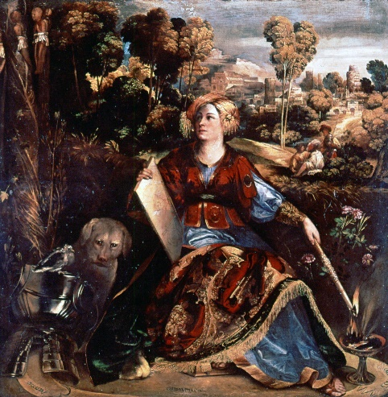
- What is in the bag, the gift that Aeolus gives to Odysseus and his crew on page 120? And what is left out of the bag, to help Odysseus?

- When Odysseus falls asleep, why do the men open the bag? (pages 120-121) And what happens when they open it? (page 121)

- Why doesn’t Aeolus help Odysseus a second time?

The Land of the Laestrygonians
- “Antiphates gave them a murderous reception” (page 122). What does Antiphates do to one of
Odysseus’s men, who were sent to check out the island?

- How does Odysseus escape from the Laestrygonians? (122-123)

The Island of the Sorceress Circe
- Pay close attention to the description of her house and Circe herself. What details do you feel are significant? Why? Describe the behavior of the “mountain lions and wolves” (124-126) that surrounded Circe’s house.

- Describe what happens when the men drink the “potion of Pramnian wine” (125) that Circe gives to
them. What do they become?

- Odysseus goes out to rescue his men and meets Hermes on the way. Hermes explains, pages 126-
127, how he can defeat Circe’s magic. List three things he must do:

a.

b.

c.

- What does Circe promise Odysseus before he will go to bed with her?

- How long do the men stay with Circe? And what do they do while they’re there?

- How have the men changed after they are returned from pigs to human (page 129)?

Time to Leave

- After Circe agrees to let the men leave, describe what she tells them they must do on their journey home (pages 131-132)

- Before they leave, what happens to the young crew member, Elpenor?

