NAME: Date:
The Odyssey – Book V “Hermes is sent to Calypso’s Island; Odysseus Makes a Raft & is Carried to the Coast of Scheria”
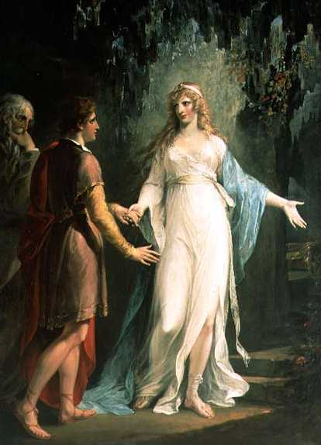
Background to Book V:
The next morning, Telemachus tells Menelaus about his problems with the suitors and asks if he has news of Odysseus. The king is disgusted at the behavior of the suitors and hopes Odysseus can mete out their punishment. He tells of how, on his return from Troy, his men were stranded on an island without any wind. They managed to capture Proteus, the Ancient of the Sea. Proteus told them that if they made a sacrifice to the gods, they could continue home. He also told him about Agamemnon's murder, and that Odysseus is a prisoner on Calypso's island.
Read The Odyssey (pages 61-74) and answer the questions below.
“The Wanderings of Odysseus Book 5: Calypso, the Sweet Nymph”
- What is the name of the messenger god?

- Where does Calypso live?

- What does Calypso promise Odysseus?

4. What is Calypso doing?

5. What objects of nature surround her? Describe the setting.

6. What does Hermes tell Calypso?

7. How did Odysseus begin to feel about living with Calypso?

8. What did Odysseus do at night? Why?

9. How did Odysseus behave during the day?

10. Why does Calypso tell Odysseus he would likely want to stay on the island with her?

11. What questions does Calypso ask Odysseus?

12. According to Odysseus, how does Calypso compare to his wife?

13. Where does Odysseus want to sail?

14. Who makes sailing difficult for him?

15. What happens to Odysseus’s raft?

16. Where does Odysseus land?

17. What does Odysseus do once he lands?

