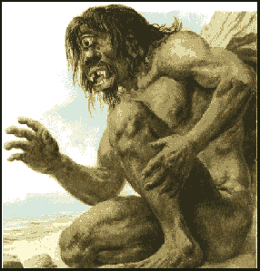
The Odyssey Book IX – How Odysseus Visited the Lotus-eaters and the Cyclops Reading Questions (pgs. 105-119)
Answer the questions below. Write in complete sentences. ½ point each.
- Describe what happens in the land of the Lotus-Eaters.

- What kind of society do the Cyclops have? How do you know?

Monsters—Odysseus encounters numerous creatures in books 9-12.
As we read these books, take moment to think about what each of these represents. What could Homer be telling us about the perils of our lives?
4. List three qualities of the Lotus eaters (Be specific and include page numbers to support your response):
a. “Did no harm to men”(107)

b.

c.

7. What might the Lotus eaters represent?

8. How does Odysseus deal with the Lotus eaters?

9. List three qualities of the Cyclops (Be Specific and include page numbers to support your response):
a.

b.

c.

10. What does Odysseus yell to the Cyclops once they were on their boat?

11. What does Cyclops throw at the men?

12. What happens to the boat?

13. What do the men warn Odysseus not to do?

14. What does Odysseus tell Cyclops?

15. What does Cyclops ask Odysseus to do?

16. What does Odysseus say he wishes he could do to the Cyclops?

17. What request does the Cyclops make to his father?

18. What might the Cyclops represent?

