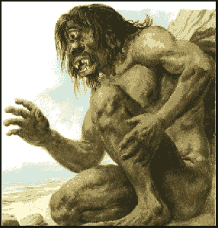
THE ODYSSEY BOOK IX ODYSSEUS CHARACTER ANALYSIS 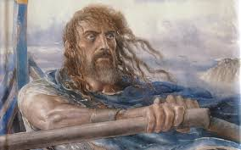
List ALL the characters identified in Book IX of The Odyssey.
_________________________________________________________________________________________________________________________________________________________________________________________________________________________________________________________________________________________________________________________________________________________________________________________________________
Review the events of Book IX. Complete the information requested for each column of the chart. Be prepared to share and discuss your responses with the class.
Summarize each episode of Book IX, focusing on how Odysseus reacts to other characters and conflicts | Analyze how Odysseus’ reactions to other characters and the events in Book IX develop his character and reveal his conflicting motivations. Be specific and use textual evidence to support your claims about Odysseus’ character. | Determine themes or central ideas developed in Book IX. To support this determination, describe both the significance of how Odysseus’ character develops the themes and the significance of Odysseus telling these episodes in flashback.

What is the significance of Odysseus’ trial(s) in Book IX in shaping his character? How does this this episode teach Odysseus to value his home and family?

_____________________________________________________________________________________________________________________________________________________________________________________________________________________________________________________________________________________________________________________________________________________________________________________________________________________________________________________________________________________________________________________________________________________________________________________________________________________________________________________________________________________________________________________________________________________________________________________________________________________________________________________________________________________________________________________________________________________________________________________________________________________________________________________________________________________________________________________________________________________________________________________________________________________________________________________________________________________________________________________________________________________________________________________________________________________________________________________________________________________________________________________________________________________________________________________________________________________________________________________________________________________________________________________________________________________________________________________________________________________________________________________________________________________________________________________________________________________________________________________________________________________________________________

