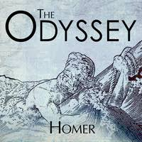
BOOK I “WHAT WENT ON IN THE HOUSE OF ODYSSEUS”
FOCUS: WRITE TWO THINGS YOU ALREADY KNOW ABOUT ODYSSEUS AND/OR THE ODYSSEY:

THE ODYSSEY BOOK I READING LOG – TODAY DURING OUR TWENTY MINUTE READING SESSION I READ PGS. _____ TO ______

AFTER READING THE PAGES LISTED ABOVE, HERE IS WHAT I UNDERSTAND:
____________________________________________________________________________________________________________________________________________________________________________________________________________________________________________________________________________________________________________________________________________________________________________________________________________________________________________________________________________________________________________________________________________________________________________________________________________________________________________________________________________________________________________________________________________________________________________________________________________________________________________________________________________________________________________________________________________________________________________________________________________________

AFTER READING THE PAGES ABOVE, I PAUSED AND ASKED, “WAIT, WHAT’S GOING ON HERE?” WHEN…………………………….(record moments of confusion or points when the text didn’t make sense to you on the lines below)
____________________________________________________________________________________________________________________________________________________________________________________________________________________________________________________________________________________________________________________________________________________________________________________________________________________________________________________________________________________________________________________________________________________________________________________________________________________________________________________________________________________________________________________________________________________________________________________________________________________________________________________________________________________________________________________________________________________________________________________________________________________

SUMMARIZE WHAT YOU READ TODAY OR WRITE TWO QUESTIONS YOU HAVE ABOUT THE ODYSSEY.
__________________________________________________________________________________________________________________________________________________________________________________________________________________________________________________________________________________________________________________________________________________________________________________________________________________________________________________________________________________________________________________________________________________________________________________________________________________________________________________________________________________________________________________________________________________________________________________________________________________________________________________________________________________________________________________________________________________________________________________________________________________________________________________________________________________________________________________________________________________________________________________________________________________________________________________________________________________________________________________________________________________________________________________________________________________________________________________________________________________________________________________________________________________________________________________________________________________________________________________________________________________________________________________________________

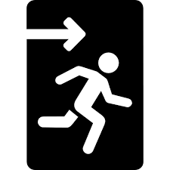
LASTLY, WHAT IS THE MOST IMPORTANT THING FOR YOU TO REMEMBER ABOUT WHAT YOU READ TODAY? WHY IS IT IMPORTANT?
____________________________________________________________________________________________________________________________________________________________________________________________________________________________________________________________________________________________________________________________________________________________________________________________________________________________________________________________________________________________________________________________________________________________________________________________________________________________________________________________________________________________________________________________________________________________________________________________________________________________________________________________________________________________________________________________________________________________________________________________________________________

